**The Circuit**

**Computer Science Department**

**CSIT 337-01 – Internet Computing**

**Spring 2024**

**Instructor:** Professor John Jenq

**Date:** May 05, 2024

**Team Circuit Team Members**

Team Leader: Xavier

Co-Leader: Dhruv Rana

Daimon Wich

Harrison Lessner

**1. Team Meeting Logs**

Our main meeting place is on Discord, while we share files through Google Drive.  
  
Meeting times:  
 4/19/2024 at 8pm - Creation of the login page and home page  
 4/20/2024 at 8pm - Setting up of the databases

4/25/2024 at 8pm - Cart Page Created

4/28/2024 at 8pm - Design Created  
 4/30/2024 at 8pm - Design Finalized

5/1/2024 at 8pm - Report Almost Finished

5/3/2024 at 8pm - Website is now functional

5/4/2024 at 8pm - Website Design is completed alongside a demo filmed.

**2. Contribution Report**

**Xavier Warner - 30%**

* Team Leader
* Finalized Design
* Set up database
* Selected images
* Created navigation bar
* Created create account page
* Created and finalized product page.

**Dhruv Rana - 27%**

* Created Cart Page
* Finalized Login Page
* Set up user purchases database
* Set up cart features like connecting to user ID and password hashing.

**Harrison Lessner - 23%**

* Created initial design
* Wrote report
* Tested implemented features
* Made minor adjustments to the code
* Organized Folders.
* Created powerpoint presentation

**Damon Wich - 20%**

* Created admin view page
* Created delete function for products on the admin page
* Created admin database
* Updated some of the pages to the current design.

**We all organized meetings together**

**3. Project Summary**

The purpose of this website is to make a website that allows users to buy and sell their owned PC Parts. This is similar to the Facebook marketplace but instead of selling and buying anything there, we are only selling and buying computer parts.

The motivation behind this website is that computer parts have skyrocketed in price over the years due to scalpers or just unfair prices from high-up companies. So team Circuit has decided to make an online e-store specifically tuned to computer parts so customers can shop online.

Our website is an e-store to allow customers to do online shopping. Although this e-store is specifically tailored to selling and buying computer parts. High-up companies do not sell these computer parts, but instead, they are sold by users themselves.

**4. Table of Contents**

| Page Types |  |  |  |
| --- | --- | --- | --- |
| **Login Pages** | Login Page | Create Account Page |  |
| **Admin Pages** | Admin View Page |  |  |
| **Databases** | Cart Database | Items Database | Users Database |
| **Cart Pages** | Cart Page | Checkout Page |  |
| **Product Related Pages** | Add Product Page | Products Page | Editing Form Page |
| **Profile Pages** | Profile Page |  |  |
| **Other** | Navigation Bar |  |  |

5. UI/UX Wireframes

This was taken from our Checkpoint 1 assignment.

**Layout of the Website - Site Map:**

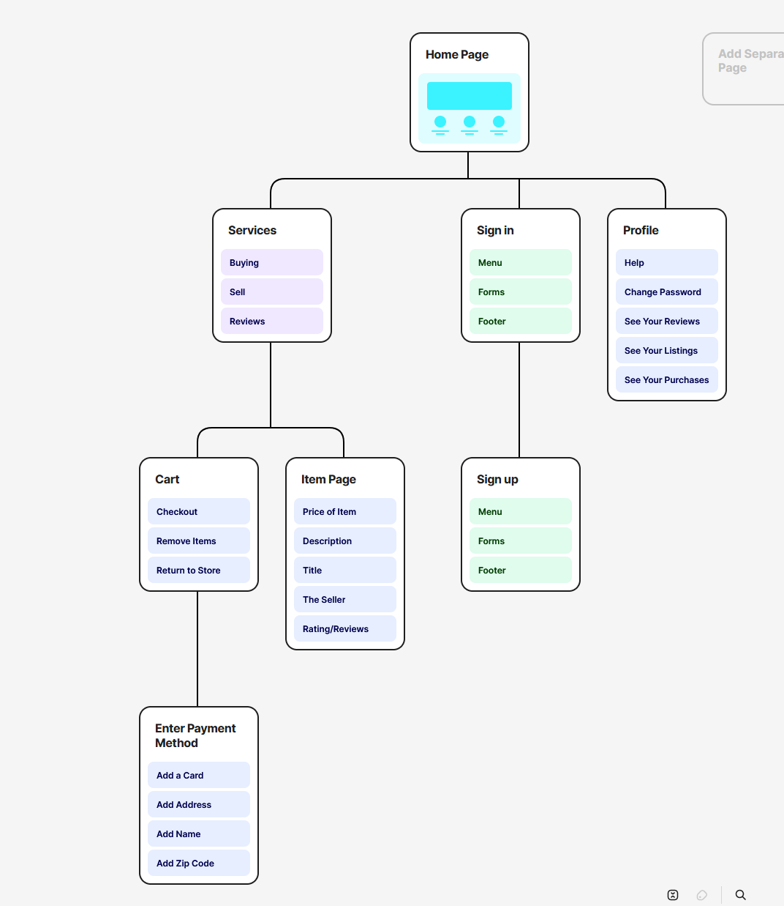

**Login Page - Wireframe:**

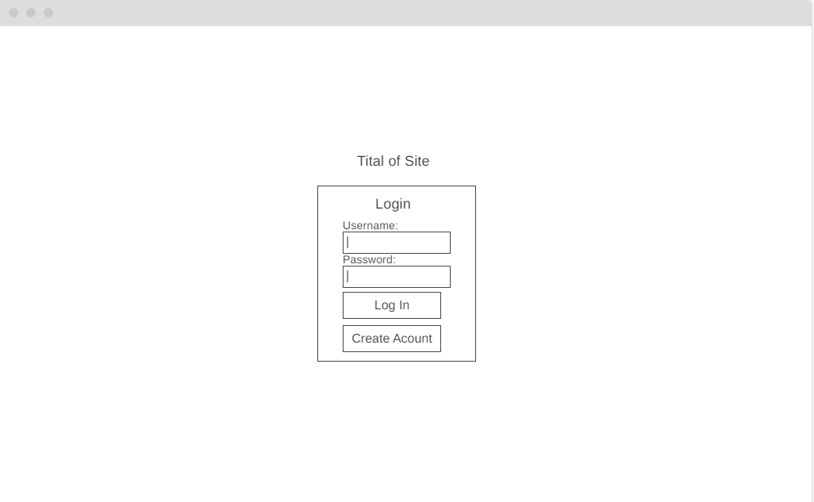

**Create Account Page - Wireframe:**

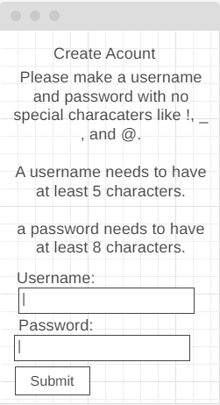

**Home Page - Wireframe:**

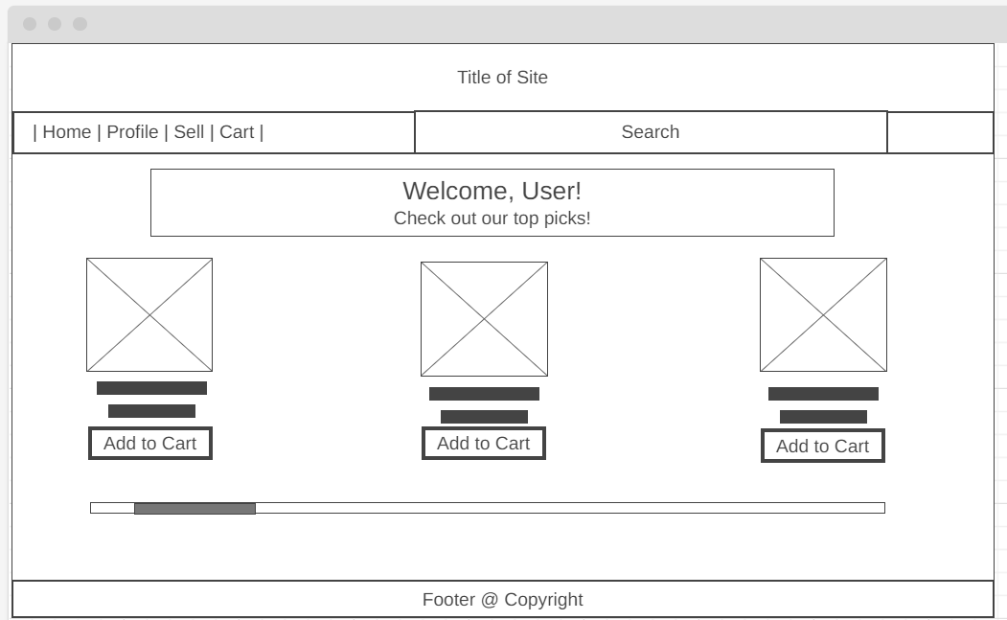

**Profile Page - Wireframe:**

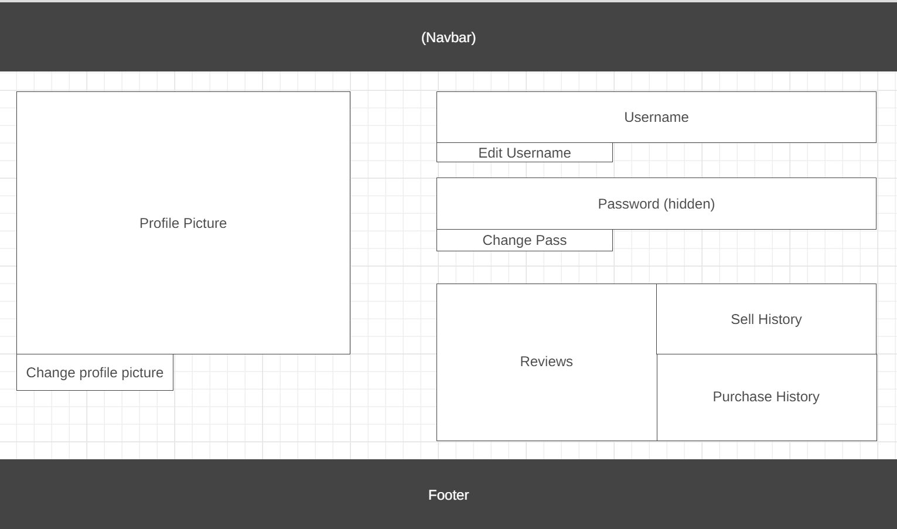

**Edit Item - Wireframe:**

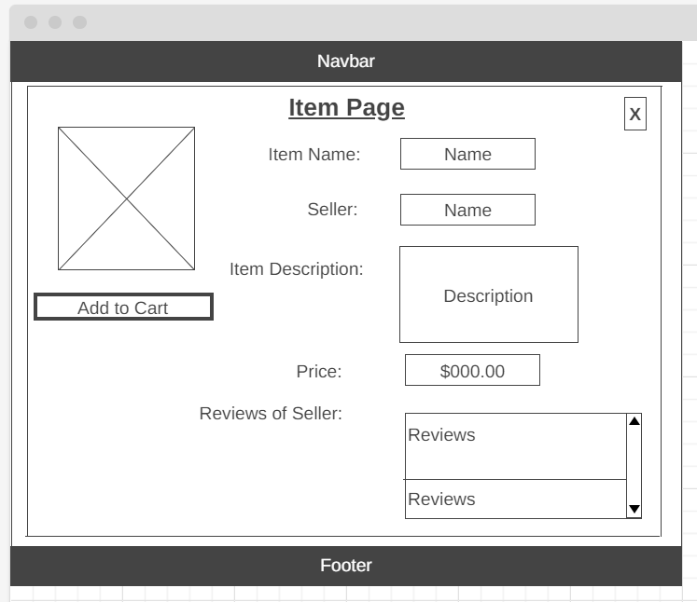

**Add Items to Home Page(Sell Page) - Wireframe:**

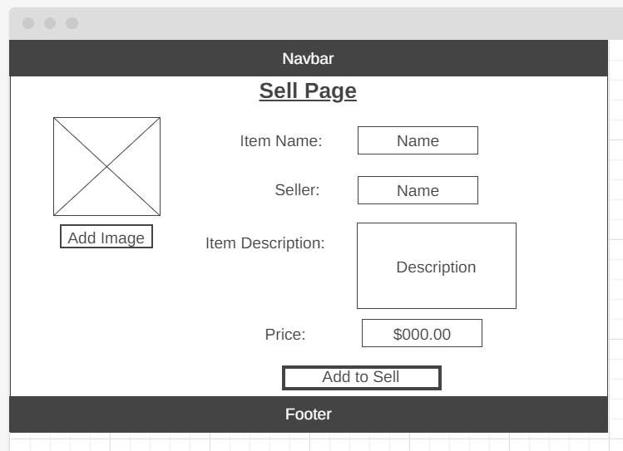

**Cart Page - Wireframe:**

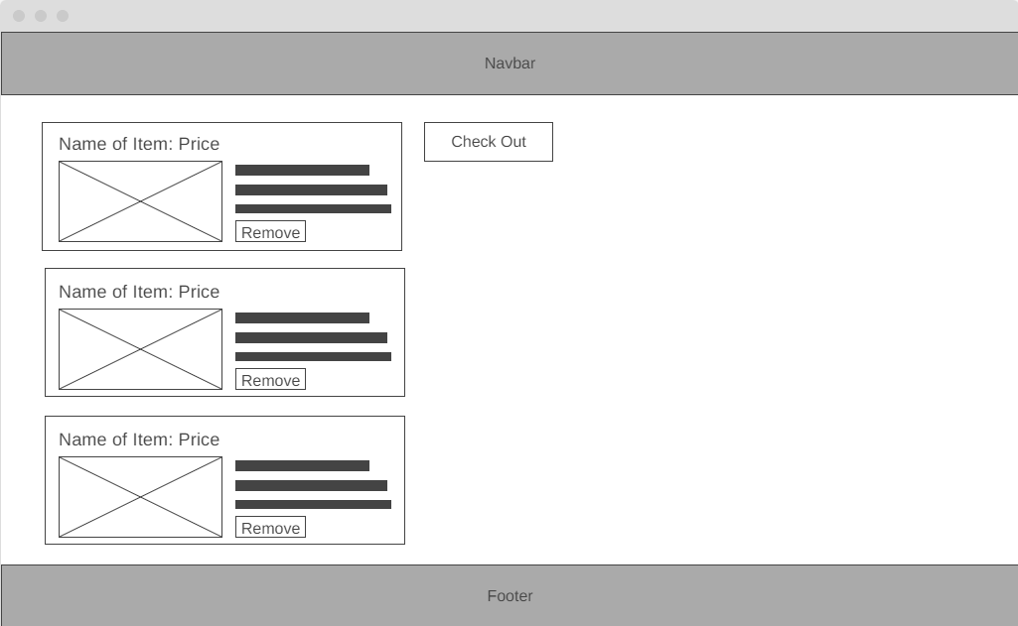

**Check Out Page - Wireframe:**

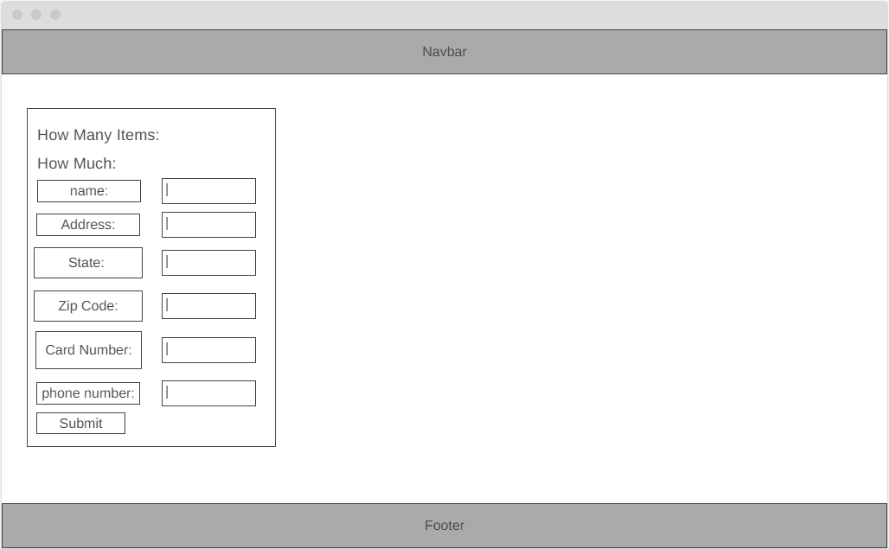

**Thank You Page - Wireframe:**

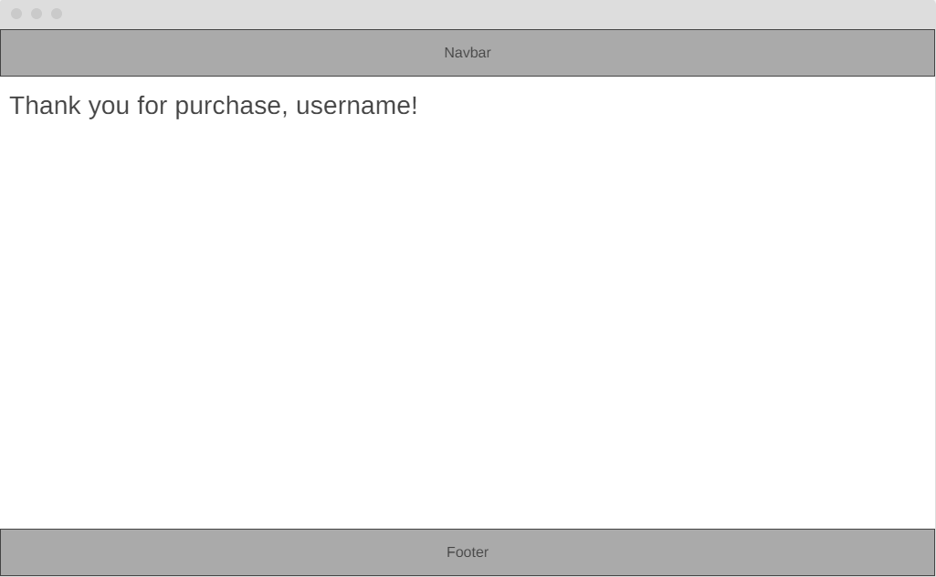

**6. User Manual**

**Logging in and out:** When the user first comes to the website, they are greeted with a login page. If the user does not have an account, they will have the option to register an account. In order to sign out, there is a logout button located in the navbar.

**Profile:** In the profile page found on the navbar, you can see your profile details. You can see your listed items on your profile and edit them if necessary.

**Buy/Sell Items:** In order to buy an item, you must explore the home page where listed items are found and find the product you want to but, then you go to the cart page in the navbar, you may edit the amount of a certain item you wish to purchase, In order sell an item, you use the Add a Product page found on the navbar.

**Checkout Page:** After selecting your items from the home page you can proceed to the checkout screen which displays everything you selected to purchase and is tied to your user ID so logging in saves your cart to your user.

**Administrator:** When logging in as an administrator, you have the option to delete listed items on the website in the main admin page. In the navbar, there is a page for admins to delete users from the website.

**7. Source Code Files**

**See attachment**

* These are in the same zip folder this was uploaded in.

**8. Database schema page**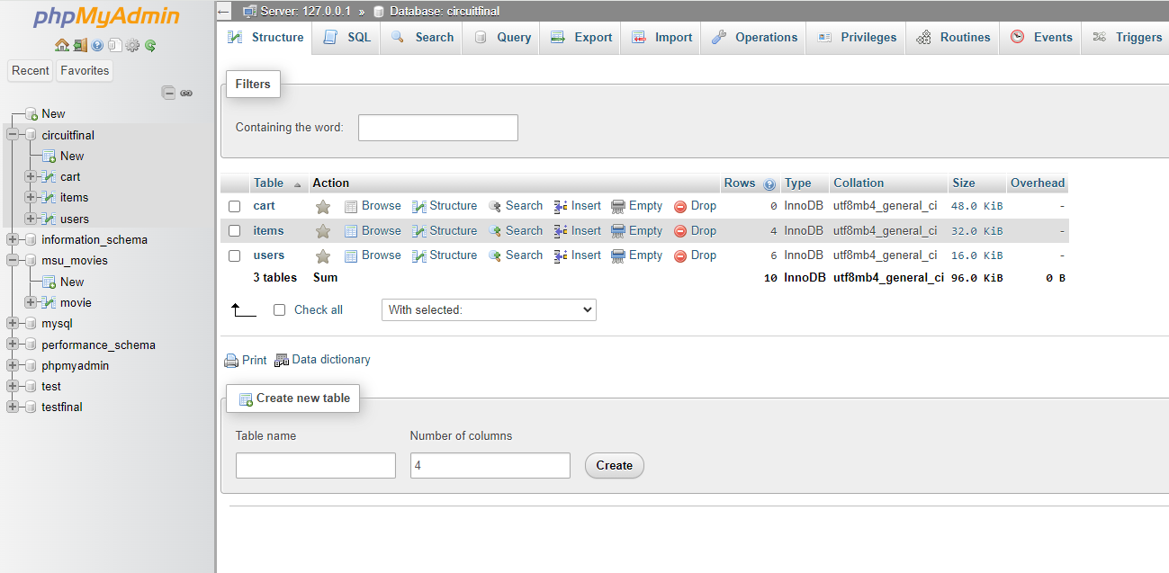

**Cart Table**

| **Column Name** | **Data Type** | **Constraints** |
| --- | --- | --- |
| cartID | INTEGER(11) | PRIMARY KEY AUTO_INCREMENT |
| buyerID | INTEGER(11) | FOREIGN KEY (references Users(User ID)) |
| itemID | INTEGER(11) | FOREIGN KEY (references Items(Item ID)) |
| quantity | INTEGER(11) | NOT NULL |

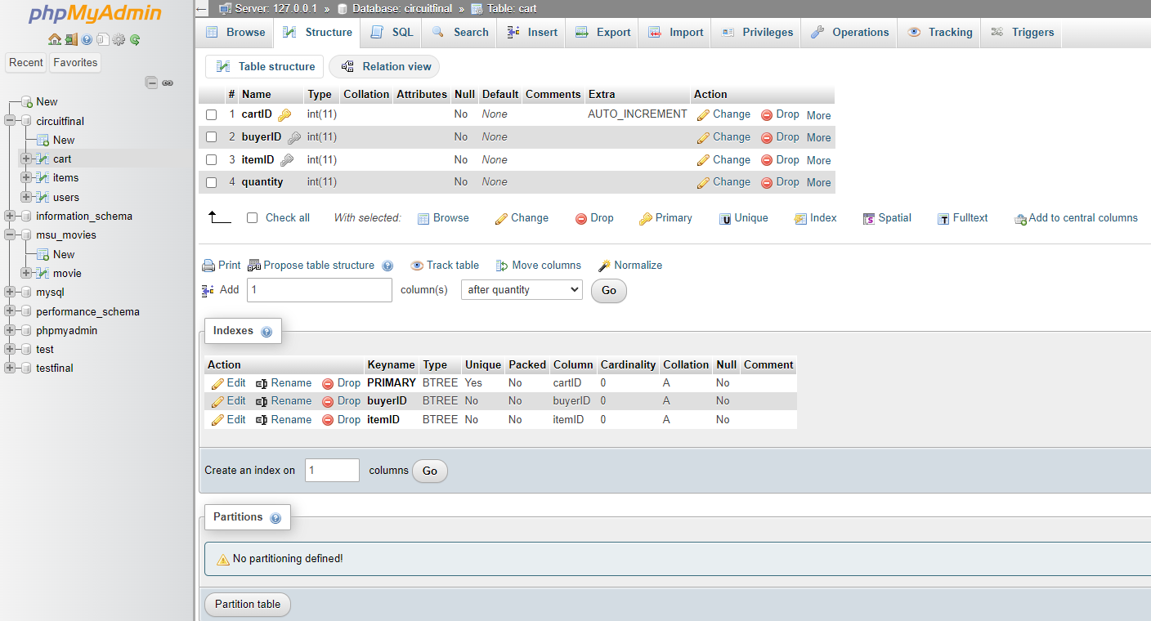

**Items Table**

| **Column Name** | **Data Type** | **Constraints** |
| --- | --- | --- |
| itemID | INTEGER(11) | PRIMARY KEY AUTO_INCREMENT |
| userID | INTEGER(11) | FOREIGN KEY (references Users(User ID)) |
| Title | VARCHAR(255) | NOT NULL |
| Description | TEXT | NOT NULL |
| Price | DECIMAL(10,2) | NOT NULL |
| ListingDate | DATE | NOT NULL |
| Status | VARCHAR(100) | NOT NULL |
| Image | VARCHAR(255) | DEFAULT NULL |

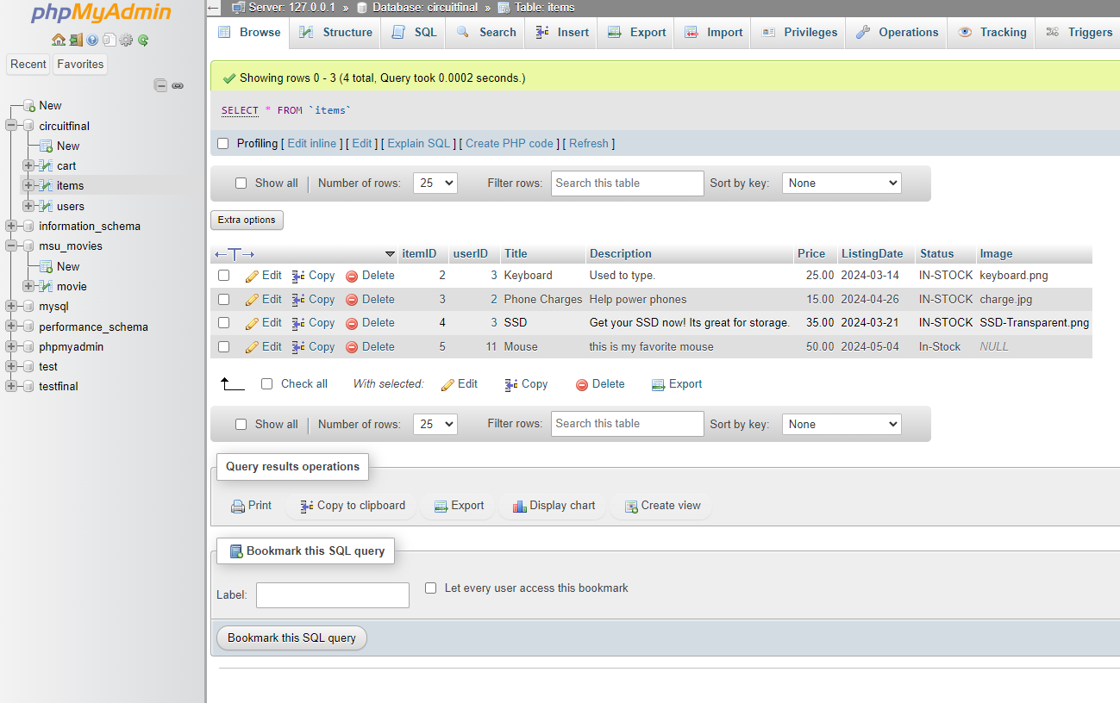

**Users Table**

| **Column Name** | **Data Type** | **Constraints** |
| --- | --- | --- |
| userID | INTEGER(11) | PRIMARY KEY AUTO_INCREMENT |
| username | VARCHAR(255) | NOT NULL |
| emailAddress | VARCHAR(255) | NOT NULL |
| password | VARCHAR(255) | NOT NULL |
| is_admin | TINYINT(4) | NOT NULL |

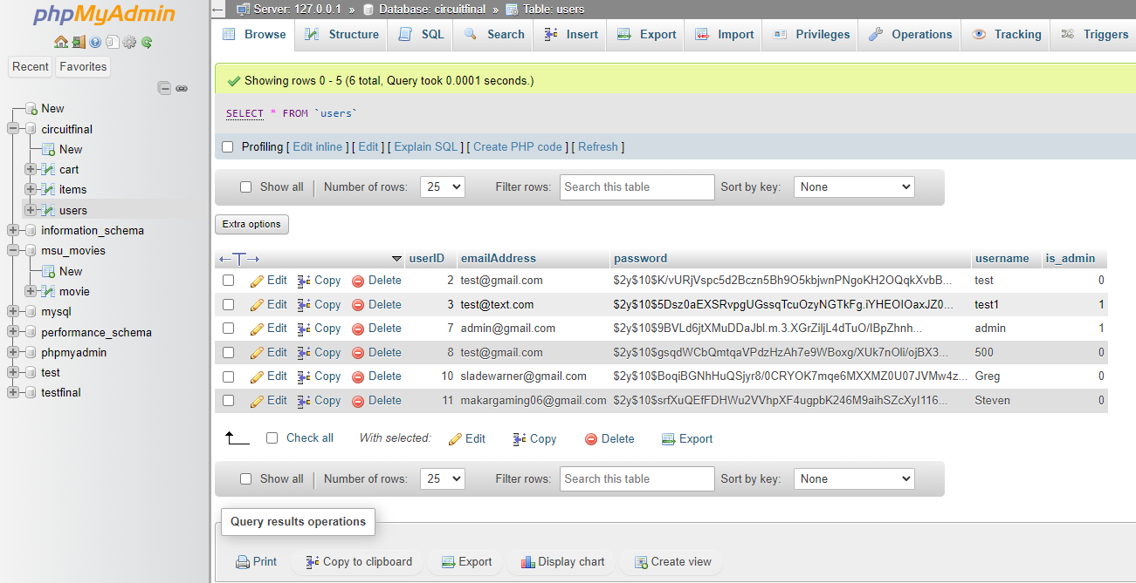

* Please see the databases folder for the SQL script file
* Our test account has access to the SQL script file and the databases, the user passwords are hashed so there is no security risk to our users.

**9. Website Testing**

**The first page a user will see is the login page**

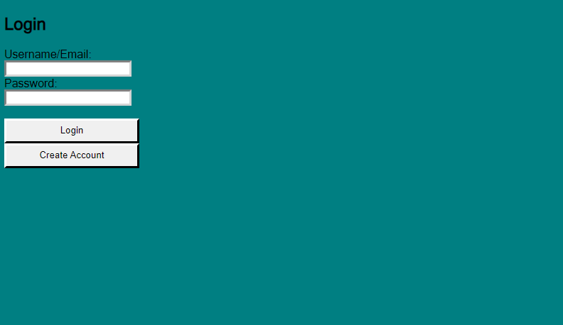

**This is what the user will see after clicking on the Creating Account page**

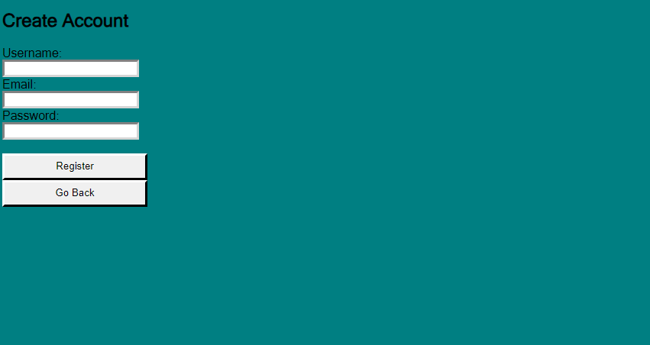

**After a user creates a new account it will bring them to the login page. Where they can log in with their new account or another person can log in with their existing account. After a user logs in they will be shown the home page.**

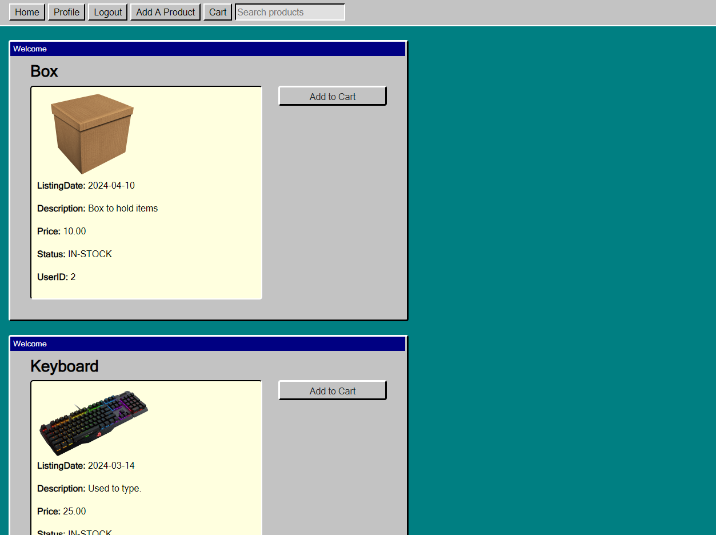

**When a user clicks on the profile button on the navbar they will be sent to the profile page**

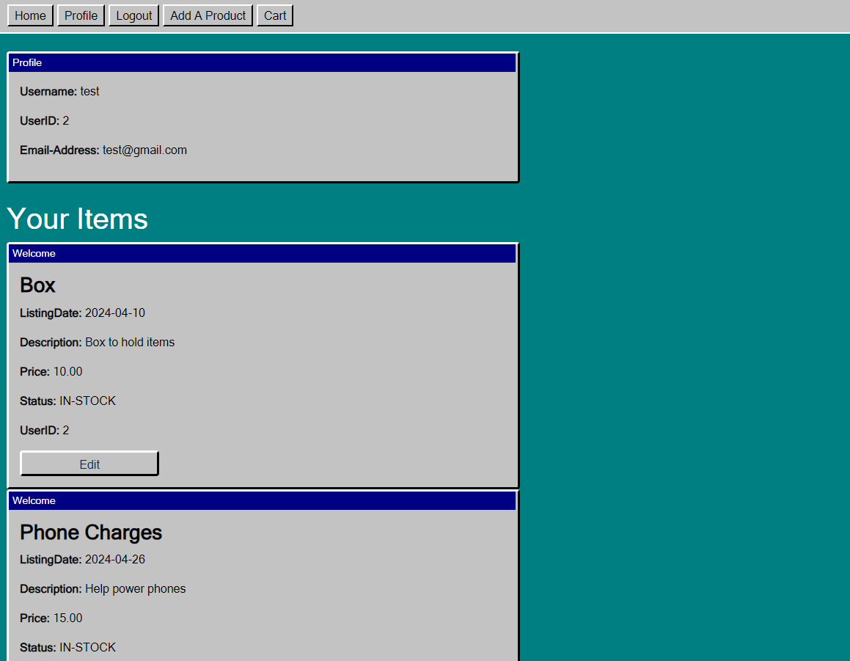

**On the profile page if the user clicks on the edit button they can then edit the items that they are selling and a forum will be shown for them to change.**

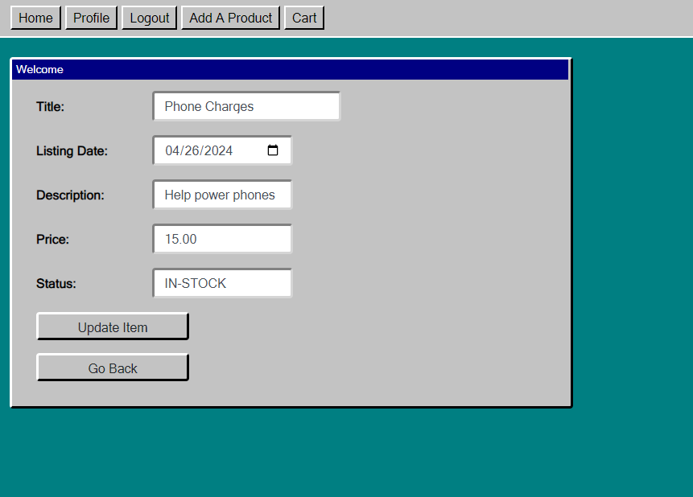

**On the home page when a user clicks on add the item to the cart and then clicks on the cart page. This will be shown. Where they can edit the amount of the product they want, remove a product from the cart, and purchase the items they want.**

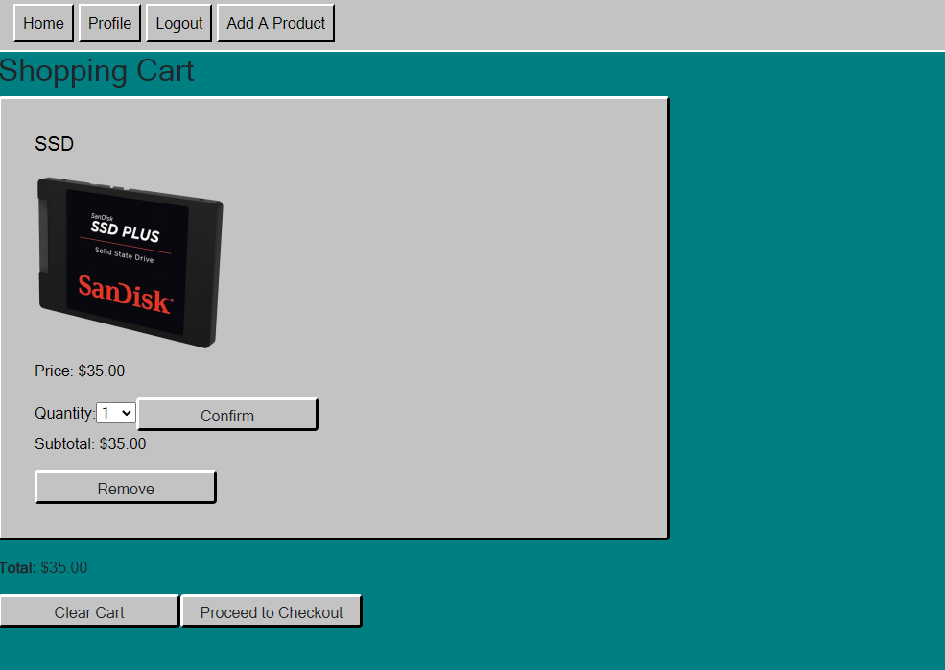

**After a user clicks on the proceed checkout button they will be sent to a forum where they put the required information so that their product can be purchased and sent to them.**

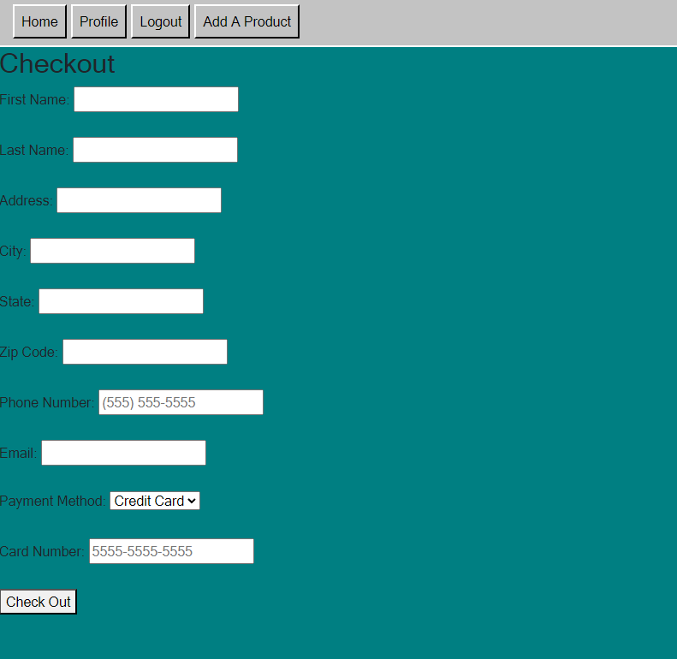

**After a user puts in all the information in the forum and clicks on the checkout button they will be sent to a thank you page confirming their purchase and giving them the information of their purchase.**

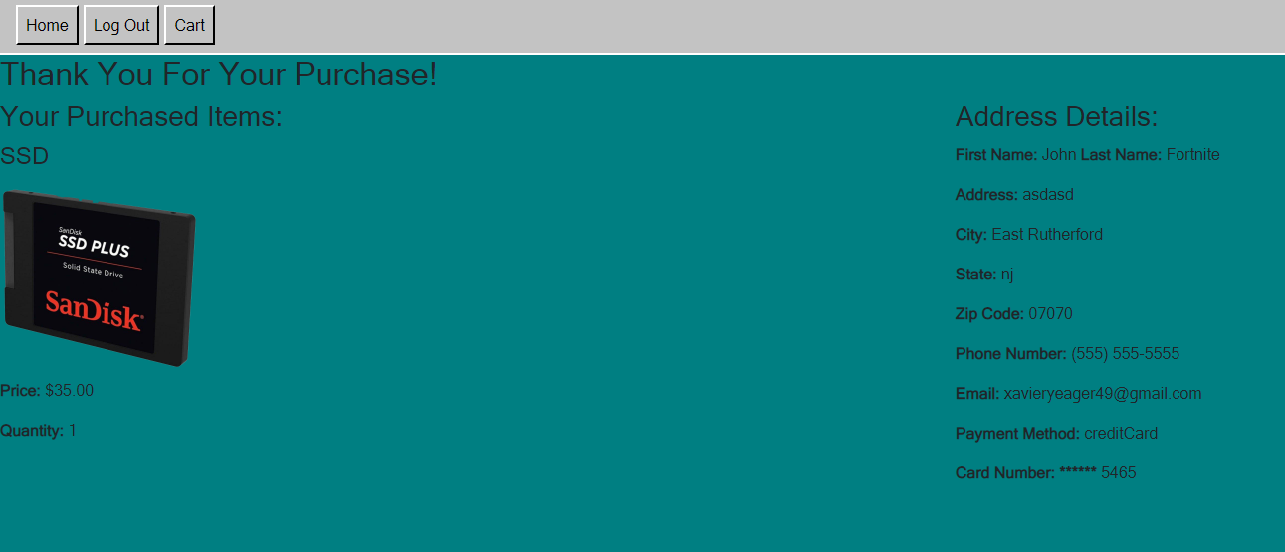

**10. Demo Video**

**Youtube Link:**

<https://www.youtube.com/watch?v=D-5ORZK7GhE>